TO: Principal Investigators on SRAC Projects

SUBJECT: REQUEST FOR A NO-COST BUDGET REVISION

Written requests for a no-cost budget revision should be made as soon as the need for the revision is evident. The request should be made using the format shown on the next page. Note that a full, but concise, explanation of the need for the revision must be part of the request. Revisions must not affect the total annual budget for the participating institution and under no circumstances should budget revisions be made to allow work outside the framework of the original project proposal. If possible, please submit your revision or explanation of need on University letterhead.

When considering a no-cost budget revision, please remember the following:
- A budget revision is not necessary when 10% or less of the total annual budget is affected.
- Faculty salaries can only be paid for 9-month appointees (3 months Summer salary) with evidence of appointment.
- Travel to scientific meetings will only be paid when documented with an accepted abstract or conference list of presenters.

As Principle Investigator, you should submit the request to the SRAC Director for review and approval. If you have additional questions concerning this budget revision, please contact Kristen Thompson at 662-686-3269 or srac@drec.msstate.edu.

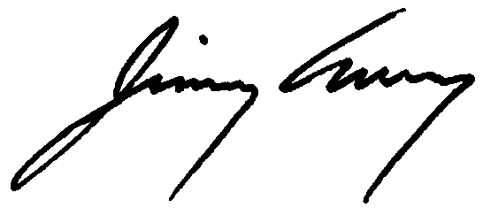
Sincerely,

Jimmy Avery, Ph.D.
Director, USDA NIFA Southern Regional Aquaculture Center
Extension Professor, National Warmwater Aquaculture Center
Mississippi State University
662-686-3273
jimmy.avery@msstate.edu

DATE:

TO: Jimmy Avery. Director, SRAC

SUBJECT: Budget Revision of Year X of SRAC Project “(Title of Project)”

I would like to request a budget revision for the (Name of Institution) portion of Year X of the SRAC project “(Title of Project)” as follows:

Current Budget Revised Budget
Salaries & Wages $ $
Fringe Benefits $ $
Materials & Supplies $ $
Nonexpendable Equipment $ $
Travel $ $
Contractual Services $ $
Total $ $

This budget revision is necessary because (explain the basis for the request).

REQUESTED BY: APPROVED:

_________________________________ _________________________________
Principal Investigator Date Jimmy Avery, Director, SRAC Date

